Papers written by
Australian Maths Software

SEMESTER ONE

MATHEMATICS APPLICATIONS

UNIT 1

2015

SOLUTIONS

SECTION ONE
1. (a) A = (2πr) × h
A = 2π× 4 × 12 ✓
A = 96π cm² ✓
(b) V = πr²h
V _{beans} = 0.97×π×4²×12 cm³
✓ ✓ ✓
(5)
2. (a) (i) Column matrix D 4 × 1 ✓✓
(ii) Identity matrix C 2 × 2 ✓✓
(iii) Row matrix B 1 × 3 ✓✓
(iv) Zero matrix E 3 × 3 ✓✓
(v) Square matrix A 2 × 2 ✓✓
(b) (i) 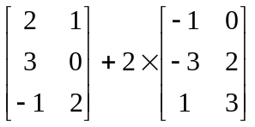
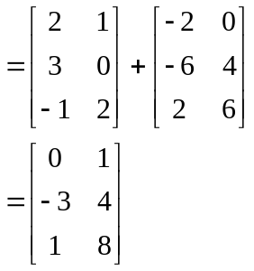
✓
✓
(ii) 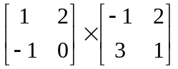
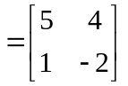
✓✓ -1/error

(c) 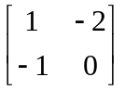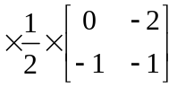

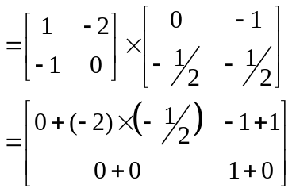
✓
✓
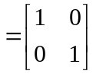 ✓
(17)

3. 500 grams costs 500 cents i.e. one cent per gram. ✓
The 650 box of corn flakes would cost 650 cents ✓
but it only costs $5.80.
The 650 gram box is relatively the cheaper. ✓
(3)
4. (a) 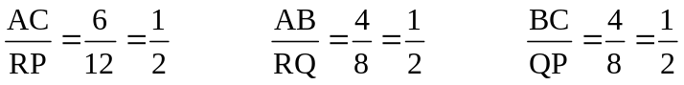 ✓✓
There are three pairs of proportional sides, so the triangles are similar. (SSS) ✓

(b) 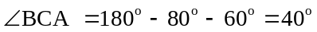
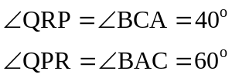
✓
✓
Two angles in one triangle are equal to two angles in the other triangle,
so the triangles are similar. (AA) ✓
(6)

5. (a) 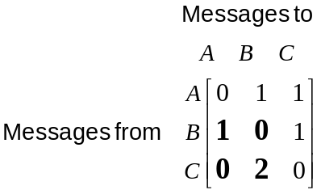
✓✓ -1/error

(b) C cannot communicate directly with A. ✓
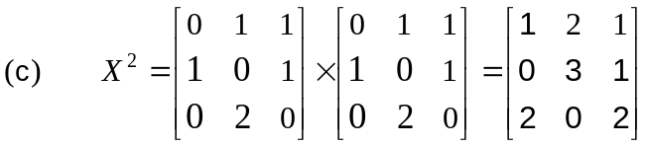
✓✓✓ -1/error

(d) There are 2 ways of a message leaving A and going to B (via C) in two stages. ✓
(7)

6. (a) 10 000 × $0.08 = $800
✓ ✓
(b) 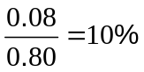
✓ ✓
(c) PE = 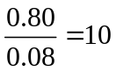
✓ ✓

(d) The company PQR Mining has a PE = 7.5.
This company represents better value because as the earnings per share increases
the PE goes down.
Say the companies were both worth $0.80
Then PE_{ABC} = 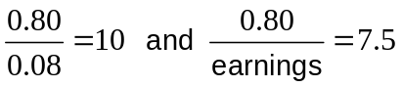

To obtain the smaller 7.5, the number you divide by, the earnings must be bigger.
✓✓ Any reasonable explanation

(e) (i) 10 000 at 20 cents profit
10 000 × $0.20 = $2 000
✓ ✓

(ii) The broker charges brokerage i.e. a charge for both buying and selling the
shares. ✓✓
(12)

END OF SECTION ONE
SECTION TWO
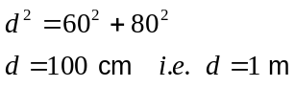7. (a)
✓
✓
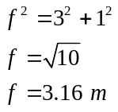 (b)
✓
✓
✓

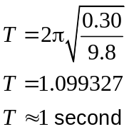 (5)
8.
✓
✓
✓

(3)
9. (a)
Red Snapper
Length in cm | Weight in kg
30 | 0.350
40 | 0.847
50 | 1.683
60 | 2.948
70 | 4.737
80 | 7.143
90 | 10.262
100 | 14.191

✓✓✓ -1/error
(b) A Red Snapper that weighs 0.847 kg was approximately 40 cm long.
Therefore the Red Snapper that weighed 0.56 kg is expected to be less than 40 cm in length. ✓
The fisherman should let the fish go. ✓
(5)
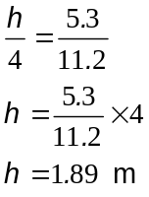10. (a)
✓✓
✓
✓
The man is 1.89 m tall
(b) (i) 7 + 12 = 19 km ✓

(ii) The lake on paper is 3.5 cm wide ✓
i.e. the real lake is approximately 7 km wide at the widest point. ✓
(7)

11. (a) 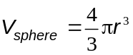
(i) 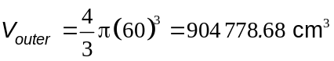 ✓ (ii) 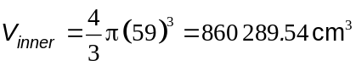 ✓

(b) (i) Amount of metal required is 44 489 cm³. ✓✓

(ii) V = 0.044 489 m³ ✓

(c) 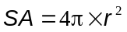 ✓
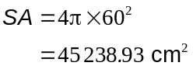
✓
(7)

12. (a) 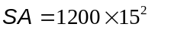✓
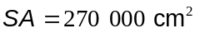✓

(b) 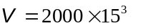 ✓
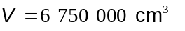✓

(c) 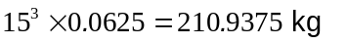 ✓
Cost = 10 × 210.9375
Cost = $2109.38 ✓
(6)
13. (a) Perimeter = 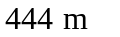✓ Area = 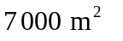✓✓

(b) Perimeter = 600 m ✓

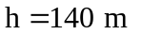 ✓
Area = 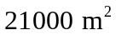 ✓✓
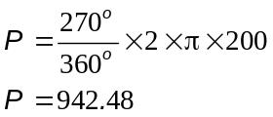
✓
(c) Around outside
✓

Total perimeter = 942.48 + 200 + 200
= 1342.48 m ✓
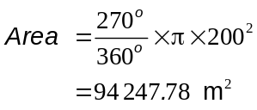
✓
✓

(12)

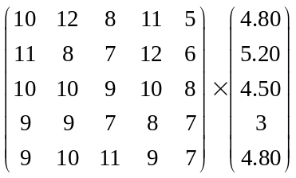14. (a)

✓✓ -1/error
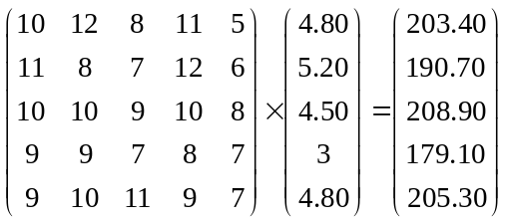
(b)

✓✓✓ -1/error

$203.40 + $190.70 + $208.90 + $179.10 + $205.30 = $987.40
✓ ✓
(7)

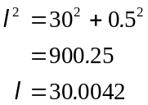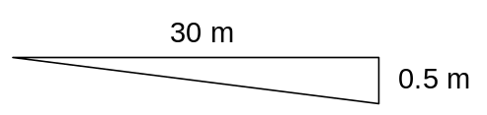15. (a) (i)
✓
✓
✓

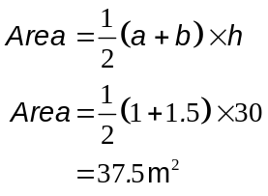
(ii)
✓
✓

✓
(iii) 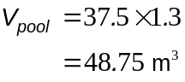
✓

✓
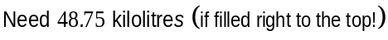

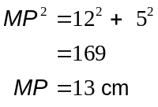
✓
(b) (i)

✓

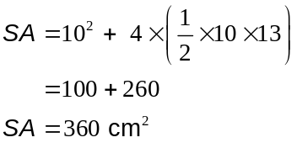
✓✓
(ii)

✓

(13)

16. (a) A Week : $9 × 30 = $270 ✓
Year : $270 × 52 = $14 040✓

B $1500 × 12 = $18 000 ✓

The best financial option is option B ✓

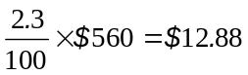
✓✓
(b)

Sally’s increase per week in 2015 is $12.88

(c) (i)
Item | Weekly cost | Monthly cost
Rent | 240 | 1040
Electricity |  | 120
Gas |  | 60
Mobile phone |  | 45
Car |  | 155
Food |  | 250
Social | 36 | 156
 | Total | $1,826
 | Monthly nett pay | $2,723

✓✓✓ 1/error

✓

(ii) $2723 - $1826 ✓
= $897 ✓

(iii) Social activities, mobile phone ✓✓

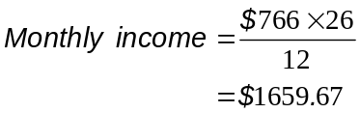
✓
(d)
✓

No, Tom cannot afford to pay his bills. Tom needs $1826 but only has $1659.67
coming in per month. ✓
(17)

17. (a) Total US cost = $235 + $23.70
✓
= $258.70
✓
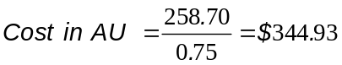

✓
✓

(b) Cost in Australia
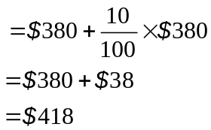
✓

(4)

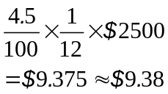
✓
18. (a)
✓

(b)
Month | Opening Balance | Interest | Closing Balance
6 | 2547.23 | 9.55 | 2556.78

✓ ✓ ✓
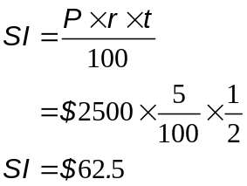
(c)

✓

✓
So the investment using simple interest is worth $2562.50
✓
which is more than investing at 4.5% CI for the 6 months.
(8)

19. (a) Discounted price = 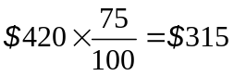
✓ ✓

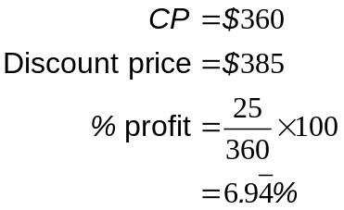
✓
(b)
✓
✓
✓

(6)

END OF SECTION TWO

